IMAT3451 Final Year Project Periodic Progress Report
Programme/Course Title: G40051 Computer Science BSc(Hons)

Name: Mohit Gautam Assessment Period:3

Project Title: Table4Me app Report Number:18/10/17-15/11/17
_______________________________________________________________________

Objectives for Period: (refer to previous report)
Some of the objectives for this period are:
- To attend second group meeting with my supervisor
- To understand what task has to be done next, after submitting the literature review.
- To send drafts of literature review and functional requirements to my supervisor to have a look at.
- To finish literature review and functional requirements.
Summary of Progress for Period: (identify evidence of progress)
- During this period, I completed all my four forms and signed them off and kept them safe.
- I started researching for my literature review by looking at articles and books relating to my app.
- I started writing my literature review and my functional and non-functional requirements for my app.
Problem Areas and Suggested Solutions:

- I was struggling with finding articles related to my app, however asking my class mates who recommended me a good website of online articles solved my problem.
- Asking supervisor for a feedback of work done so far helped to build my confidence.
________________________________________________________________________

Objectives, Deliverables & Plan for Next Period:

- To attend one to one meeting with my supervisor
- To start designing my app.
- To start drawing rough sketches, case diagrams, and uml diagrams for my app.
- To learn android studio through tutorials and start creating the app.

Date of Next Review:05/12/17
________________________________________________________________________

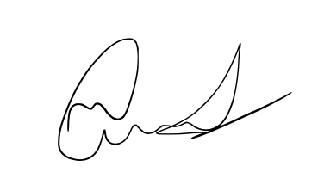
Student’s Signature: Date:

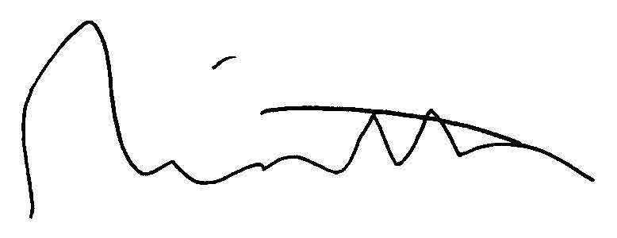

Supervisor’s Signature: Date:25/10/17

